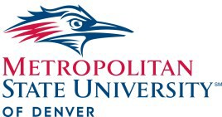2017PianoCelebration
Metropolitan State University of Denver Department of Music
Campus Box 58
PO Box 173362
Denver, CO 80217-3362 AAVP70

Schedule of Events

Friday, February 25th

Morning

8:30 Registration

9:00 – 12:00 Achievement Day One-on-One Sessions: Private adjudicated sessions for beginning, intermediate, and advanced levels

Afternoon

12:00-1:00 LUNCH

1:00 – 2:00 Two Piano Extravaganza Concert: Featuring guest artist Woori Kim

2:30 – 4:00 Master Class with MSU Denver Piano Faculty

4:00 – 5:00 Achievement Day Honors Showcase

5:00 – 6:00 Closing Reception

L o c a t i o n
The MSU Denver Piano Celebration will be held in the beautiful Kenneth King Center located at 855 Lawrence Street in the heart of Downtown Denver.

Registration

Register on the piano celebration website
www.pianocelebration.org
For more information on Music at MSU Denver, please call 303-556-3180 or visit www.msudenver.edu/music

Music at MSU Denver

Presents the
Piano
CELEBRATION

Saturday
Feb. 25, 2017

Two Piano Extravaganza
Piano Celebration
Pianocelebration.org
Saturday February 25, 2017

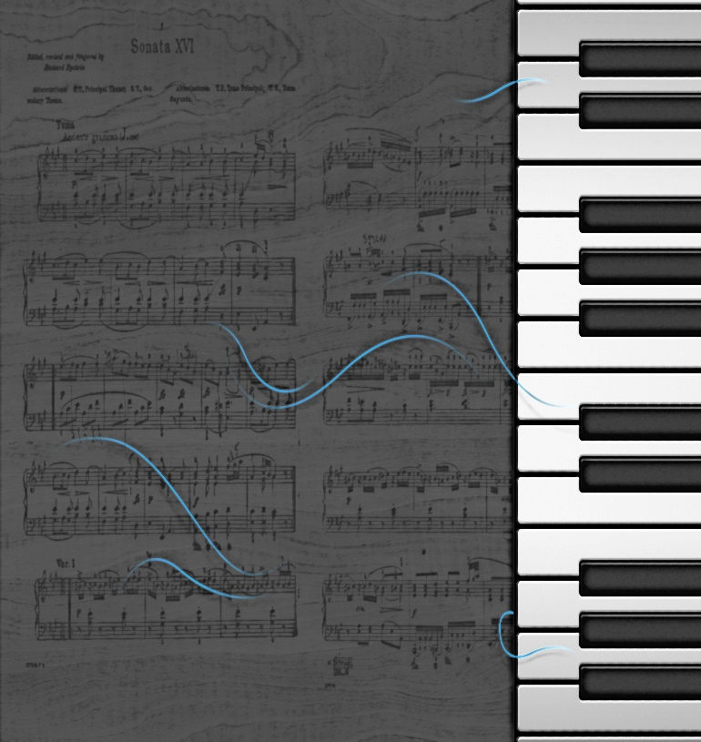

Jooeun Pak,
MSU Denver Piano Director

2017 Piano Celebration
Two Piano Extravaganza

Piano Faculty at MSU Denver

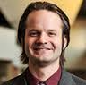
Peter Friesen is an affiliate faculty at MSU Denver, where he teaches both class piano and private piano lessons. He holds a Bachelor of Arts in Music from Point Loma Nazarene University in San Diego. He currently serves as the Commissioned Composer Chair for the Colorado State Music Teachers Association, and is a former President of the Broomfield Music Teachers Association. Mr. Friesen also teaches from his studio in Westminster and is a former member of the faculty at the Center for Musical Arts in Lafayette.

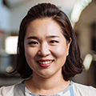
Pianist Hyun Kim has a master’s degree in collaborative piano and vocal coaching from the University of Cincinnati College-Conservatory of Music. She has been active as a solo pianist and collaborative performer as well as, a vocal coach. She is currently an affiliate faculty/staff accompanist at Metropolitan State University of Denver.

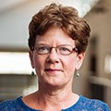
Pianist Nanette Shannon is a versatile soloist, chamber musician, and teacher. In addition to her current positions as Adjunct Instructor of Piano at Regis University and Affiliate Instructor of Class Piano at Metropolitan State University in Denver, Ms. Shannon is a frequent adjudicator for local competitions, including MTNA events, the Young Musicians Foundation in Denver, and those of the Jefferson County and Fort Collins Symphony Orchestra
Two Piano Extravaganza Concert
With Jooeun Pak and Woori Kim Saturday 1:00pm – 2:00pm
King Center Box Office: 303-556-2296
For more information about the MSU Denver piano faculty and degree programs, please visit:
www.msudenver.edu/music
www.pianocelebration.org

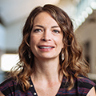
Collette St. Clair has been teaching piano professionally since 1997. She holds three degrees, a B.A. from Colorado State University, a B.M. from Metropolitan State University of Denver, and a Masters of Music from the University of Colorado at Boulder. Collette is part-time faculty at Metropolitan State University as well as, The University of Colorado at Denver. At these institutions, she teaches class piano and music appreciation. She also teaches private lessons.

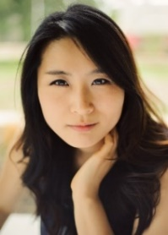
Jooeun Pak has appeared in major concert venues as a highly demanded soloist, chamber musician, and a champion of contemporary music. Since she won the Gold medal in Korean National Competition at the age of 10, Pak has won a number of prizes in national and international competitions and given performances in major cities in the U.S., Korea, Italy, Jordan, and Germany She is a faculty member of The Orfeo Music Festival and started her new post as an Assistant Professor of Piano at the University of Denver in the fall, 2016. Pak received a DM in Piano Performance and Literature.

Guest Artist
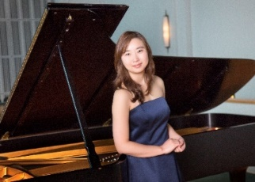
Pianist Woori Kim is a native of Busan, South Korea. After graduating summa cum laude from Seoul National University, she earned a Masters of Music and Performer's Diploma from the Jacobs School of Music of Indiana University. She completed her education at the College-Conservatory of Music at the University of Cincinnati, graduating simultaneously with a Doctorate of Musical Arts and an Artist Diploma.
She has performed at numerous international music festivals, including the Great Lakes Chamber Music Festival in Bloomfield Hills, Michigan and at the Kirishima International Music Festival in Kirishima, Japan. Additionally, she has participated in master classes in Prague, Scotland, and Salzburg under such mentors as Leon Fleisher, Jean-Yves Thibaudet, Nelita True, Robert Weirich, Ann Schein, and Jun Kanno. She has performed throughout Europe, Asia, and North America. In 2011, she was the winner of the CCM concerto competition, allowing her to perform Shostakovich's First Piano Concerto with the CCM Philharmonia. Dr. Kim has performed Beethoven's 4th Piano Concerto with the Liberty University Symphony Orchestra. She also is an active chamber musician, and performs as part of the piano duo, "Les Quatre Mains", with her husband and fellow pianist Curtis Ryan Smith.
Dr. Kim serves on the Piano Faculty at Liberty University's School of Music as an Assistant Professor of Piano, while continuing to appear in solo, chamber, and concerto performances. She has given master classes at numerous universities, including Western Kentucky University and Indiana University-Purdue University Indianapolis (IUPUI). She is also a frequent adjudicator for both state and national competitions.

Master Class
2:30pm – 4:00pm
Featuring Piano @ MSU Denver Faculty

