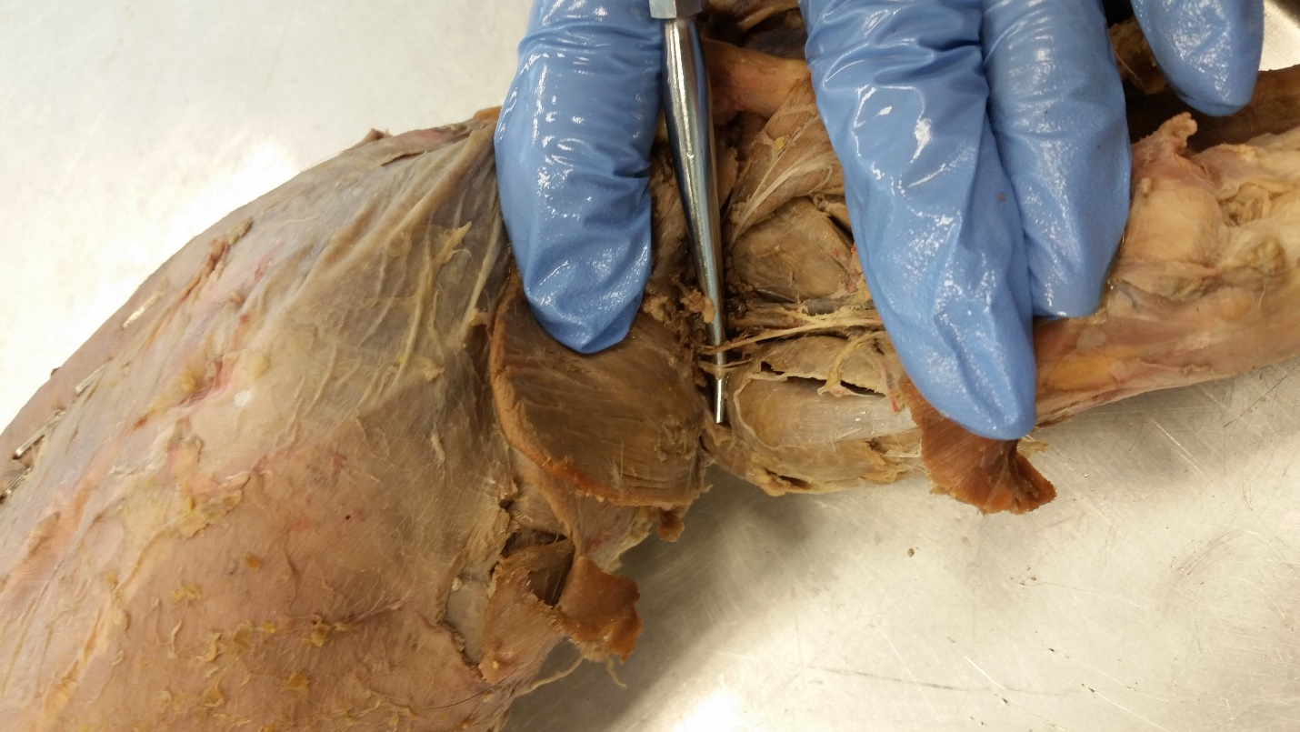

Saphenous branch of femoral nerve

Femoral nerve under probe

Quadriceps femoris