Review Sheet: Exercise 13

Gross Anatomy of the Muscular System
Name Lab Time/Date

Classification of Skeletal Muscles
- Several criteria were given for the naming of muscles.
For each of the criteria below, list at least two muscles that are named for the given criterion.
  - Muscle location:
  - Muscle shape:
  - Muscle size:
  - Direction of muscle fibers:
  - Number of origins:
  - Location of attachments:
  - Muscle action:
- Match the key terms to the descriptions below.
Key:
  - prime mover (agonist)
  - antagonist
  - synergist
  - fixator
  - origin
  - insertion
  - 1. term for the biceps brachii during forearm flexion
  - 2. term that describes the relation of brachioradialis to biceps brachii during forearm flexion
  - 3. term for the triceps brachii during forearm flexion
  - 4. term for the more movable muscle attachment
  - 5. term for the more fixed muscle attachment
  - 6. term for the rotator cuff muscles and deltoid when the forearm is flexed and the hand grabs a tabletop to lift the table

Muscles of the Head and Neck
- Using choices from the key below, correctly identify muscles provided with leader lines on the illustration.
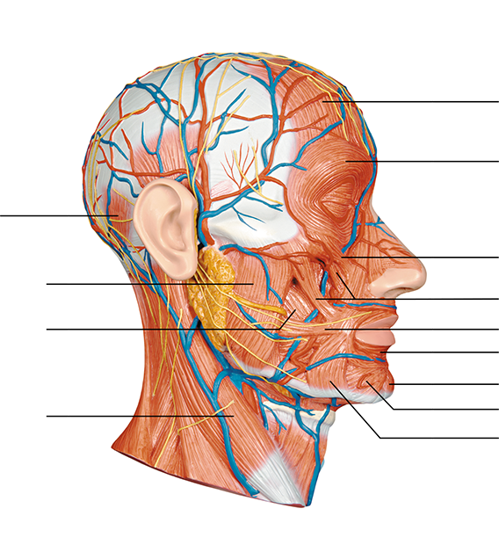
Figure 13.10-1 Full Alternative Text Description
Key:
  - buccinator
  - depressor anguli oris
  - depressor labii inferioris
  - frontal belly of the epicranius
  - levator labii superioris
  - masseter
  - mentalis
  - occipital belly of the epicranius
  - orbicularis oculi
  - orbicularis oris
  - risorius
  - sternocleidomastoid
  - zygomaticus minor and major
- Using the key provided in question 3, identify the muscles described next.
  - 1. used in smiling
  - 2. used to suck in your cheeks
  - 3. used in blinking and squinting
  - 4. used to pout (pulls the corners of the mouth downward)
  - 5. raises your eyebrows for a questioning expression
  - 6. used to turn and tilt the head toward the shoulder
  - 7. your kissing muscle
  - 8. prime mover of jaw closure
  - 9. draws corners of the lip back (laterally)

Muscles of the Trunk
- Correctly identify both intact and transected (cut) muscles depicted in the illustration, using the key given below.
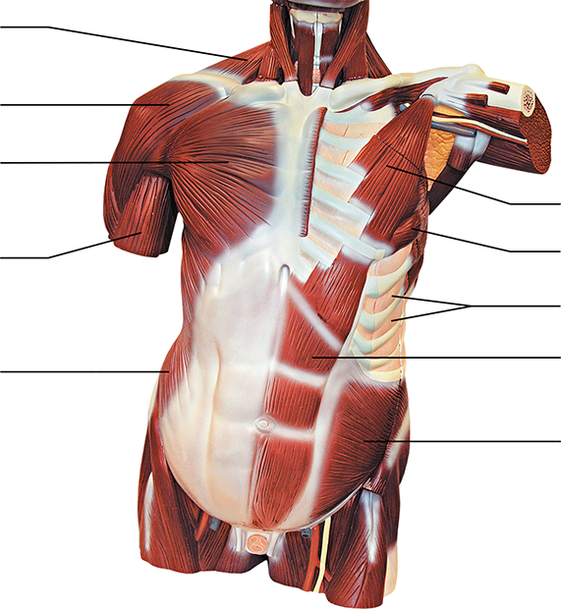
Figure 13.10-1 Full Alternative Text Description
Key:
  - biceps brachii (cut)
  - deltoid
  - external intercostals
  - external oblique
  - internal oblique
  - pectoralis major
  - pectoralis minor
  - rectus abdominis
  - serratus anterior
  - trapezius

- Using the key provided in question 5 above, identify the major muscles described below.
  - 1. a major flexor of the vertebral column
  - 2. prime mover for forearm flexion
  - 3. prime mover for arm flexion
  - 4. assume major responsibility for forming the abdominal wall (three pairs of muscles)
  - 5. prime mover of arm abduction
  - 6. with ribs fixed, pulls scapula forward and downward
  - 7. moves the scapula forward and rotates scapula upward
  - 8. small, inspiratory muscles between the ribs; elevate the rib cage
  - 9. extends the head

Muscles of the Upper Limb
- Using terms from the key below, correctly identify all muscles provided with leader lines in the illustration.
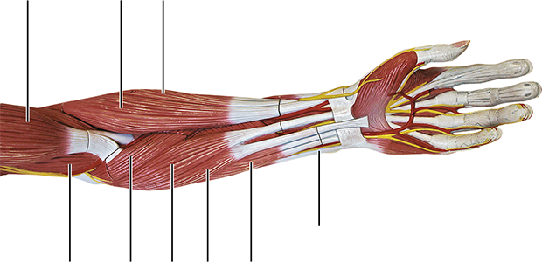
Figure 13.10-1 Full Alternative Text Description
Key:
  - biceps brachii
  - brachialis
  - brachioradialis
  - extensor carpi radialis longus
  - flexor carpi radialis
  - flexor carpi ulnaris
  - flexor digitorum superficialis
  - palmaris longus
  - pronator teres
- Use the key provided in question 7 to identify the muscles described below. (Some choices from the key will be used more than once.)
  - 1. flexes and supinates the forearm
  - 2. muscle located in the posterior compartment of the forearm
  - 3. forearm flexors; no role in supination (two muscles)
  - 4. muscle located medial to the palmaris longus
  - 5. flexes and abducts the hand
  - 6. flexes the hand and middle phalanges
  - 7. pronates the forearm
  - 8. flexes and adducts the hand
  - 9. extends and abducts the hand
  - 10. flat muscle that is a weak hand flexor, tenses skin of the palm

Muscles of the Lower Limb
- Using the terms from the key below, correctly identify all muscles provided with leader lines in the illustrations below.
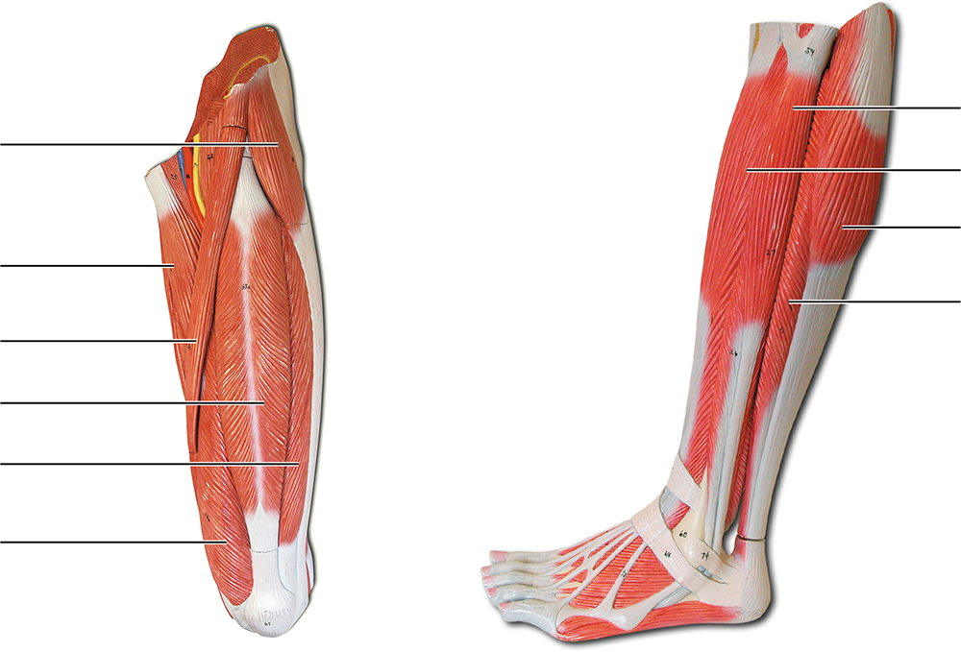
Figure 13.10-1 Full Alternative Text Description
Key:
  - adductor longus
  - extensor digitorum longus
  - fibularis longus
  - gastrocnemius
  - rectus femoris
  - sartorius
  - soleus
  - tensor facia lata
  - vastus lateralis
  - vastus medialis
- Use the key terms in question 9 to respond to the descriptions below.
  - 1. ”tailor’s muscle”
  - 2. lateral compartment muscle that plantar flexes and everts the foot
  - 3. abducts the thigh to take the “at ease” stance
  - 4. extend leg and stabilize knee (two muscles)
  - 5. posterior compartment muscles that plantar flex the foot (two muscles)
  - 6. adducts the thigh, as when standing at attention
  - 7. extends the toes
  - 8. extends leg and flexes thigh

General Review: Muscle Recognition
- Identify each lettered muscle in the illustration of the human anterior superficial musculature by matching its letter with one of the following muscle names:
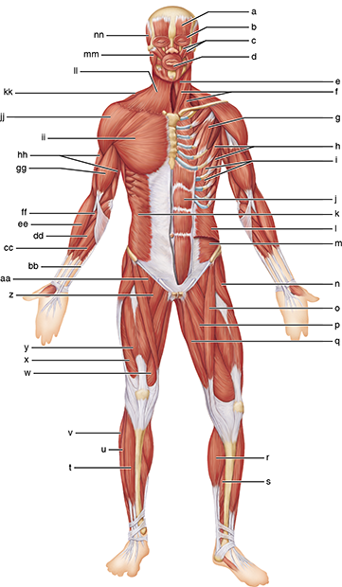
Figure 13.10-1 Full Alternative Text Description
  - 1. adductor longus
  - 2. biceps brachii
  - 3. brachioradialis
  - 4. deltoid
  - 5. extensor digitorum longus
  - 6. external oblique
  - 7. fibularis longus
  - 8. flexor carpi radialis
  - 9. flexor carpi ulnaris
  - 10. frontal belly of epicranius
  - 11. gastrocnemius
  - 12. gracilis
  - 13. iliopsoas
  - 14. intercostals
  - 15. internal oblique
  - 16. masseter
  - 17. orbicularis oculi
  - 18. orbicularis oris
  - 19. palmaris longus
  - 20. pectineus
  - 21. pectoralis major
  - 22. pectoralis minor
  - 23. platysma
  - 24. pronator teres
  - 25. rectus abdominis
  - 26. rectus femoris
  - 27. sartorius
  - 28. serratus anterior
  - 29. soleus
  - 30. sternocleidomastoid
  - 31. sternohyoid
  - 32. temporalis
  - 33. tensor fascia lata
  - 34. tibialis anterior
  - 35. transversus abdominis
  - 36. trapezius
  - 37. triceps brachii
  - 38. vastus lateralis
  - 39. vastus medialis
  - 40. zygomaticus
- Identify each lettered muscle in this illustration of the human posterior superficial musculature by matching its letter with one of the following muscle names:
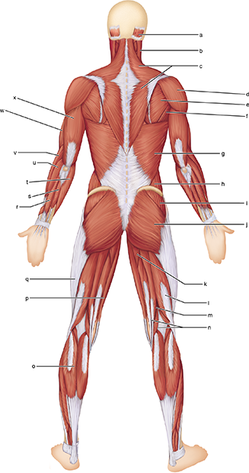
Figure 13.10-1 Full Alternative Text Description
  - 1. adductor magnus
  - 2. biceps femoris
  - 3. brachialis
  - 4. brachioradialis
  - 5. deltoid
  - 6. extensor carpi radialis longus
  - 7. extensor carpi ulnaris
  - 8. extensor digitorum
  - 9. external oblique
  - 10. flexor carpi ulnaris
  - 11. gastrocnemius
  - 12. gluteus maximus
  - 13. gluteus medius
  - 14. gracilis
  - 15. iliotibial tract (tendon)
  - 16. infraspinatus
  - 17. latissimus dorsi
  - 18. occipital belly of epicranius
  - 19. semimembranosus
  - 20. semitendinosus
  - 21. sternocleidomastoid
  - 22. teres major
  - 23. trapezius
  - 24. triceps brachii

General Review: Muscle Descriptions
- Identify the muscles described by completing the following statements. Use an appropriate reference as needed.
  - The , , , and are commonly used for intramuscular injections (four muscles).
  - The insertion tendon of the group contains a large sesamoid bone, the patella.
  - The triceps surae insert in common into the tendon.
  - The bulk of the tissue of a muscle tends to lie to the part of the body it causes to move.
  - The extrinsic muscles of the hand originate on the .
  - Most flexor muscles are located on the aspect of the body; most extensors are located . An exception to this generalization is the extensor-flexor musculature of the .
- Clinical/Critical Thinking Bruxism is a condition in which individuals clench and/or grind their teeth. It often occurs as they sleep, leading to jaw pain and damaged teeth. Which muscles contract during this nocturnal event?

- Clinical/Critical Thinking Repetitive extension of the hand at the wrist and abduction of the hand can lead to lateral epicondylitis. Although sometimes called “tennis elbow,” it more often affects individuals who don’t play tennis. Based on the name lateral epicondylitis and the action described above, which muscle would most likely have microscopic tears in the tendon?

