Review Sheet: Exercise 43

Physiology of Reproduction: Gametogenesis and the Female Cycles
Name Lab Time/Date

Meiosis
- The following statements refer to events occurring during mitosis and/or meiosis. For each statement, decide whether the event occurs in (a) mitosis only, (b) meiosis only, or (c) both mitosis and meiosis.
  - 1. dyads are visible
  - 2. tetrads are visible
  - 3. product is two diploid daughter cells genetically identical to the mother cell
  - 4. product is four haploid daughter cells quantitatively and qualitatively different from the mother cell
  - 5. involves the phases prophase, metaphase, anaphase, and telophase
  - 6. occurs throughout the body
  - 7. occurs only in the ovaries and testes
  - 8. provides cells for growth and repair
  - 9. homologues synapse; chiasmata are seen
  - 10. chromosomes are replicated before the division process begins
  - 11. provides cells for production of offspring
  - 12. consists of two consecutive nuclear divisions, without chromosomal replication occurring before the second division
- Describe the process of synapsis.

- How does crossing over introduce variability in the daughter cells?

- Define homologous chromosomes.

Spermatogenesis
- The cell types seen in the seminiferous tubules are listed in the key. Match the correct cell type or types with the descriptions given below.
Key:
  - primary spermatocyte
  - secondary spermatocyte
  - spermatogonium
  - sustentocyte
  - spermatid
  - sperm
  - 1. primitive stem cell
  - 2. haploid (3 responses)
  - 3. provides nutrients to developing sperm
  - 4. product of meiosis II
  - 5. product of spermiogenesis
  - 6. product of meiosis I
- Why are spermatids not considered functional gametes?
- Differentiate spermatogenesis from spermiogenesis.

Oogenesis, the Ovarian Cycle, and the Menstrual Cycle
- The sequence of events leading to gamete formation in the female begins during fetal development. By the time the child is born, all viable oogonia have been converted to .
In view of this fact, how does the total gamete potential of the female compare to that of the male?

- The female gametes develop in structures called follicles. Describe the structure of a primordial follicle.

- How are primary and vesicular follicles anatomically different?

- What is a corpus luteum?
- What are the hormones produced by the corpus luteum?
- Use the key to identify the cell type you would expect to find in the following structures. The items in the key may be used once, more than once, or not at all.
Key:
  - oogonium
  - primary oocyte
  - secondary oocyte
  - ovum
  - 1. forming part of the primary follicle in the ovary
  - 2. in the uterine tube before fertilization
  - 3. in the vesicular follicle of the ovary
  - 4. in the uterine tube shortly after fertilization
  - 5. primitive stem cell
- In the following illustration of an ovary, label each leader line with the letter for the correct term from the key below.
Key:
  - corpus albicans
  - corpus luteum
  - ovarian ligament
  - primary follicle
  - ruptured follicle
  - secondary follicle
  - secondary oocyte
  - vesicular (antral) follicle
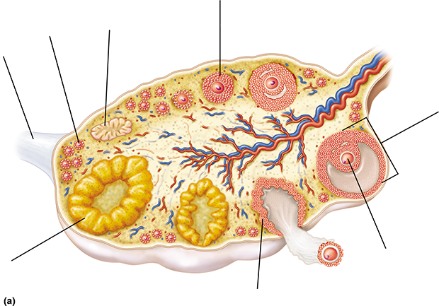
Figure 43.13-1 Full Alternative Text Description
- The cellular products of spermatogenesis are four ; the final products of oogenesis are one and three . What is the function of this unequal cytoplasmic division seen during oogenesis in the female?

Why?
- For each statement below dealing with plasma hormone levels during the female ovarian and menstrual cycles, decide whether the condition in option (a) is usually greater or less than option (b).
  - 1. (a) amount of LH in the blood during menstruation
(b) amount of LH in the blood at ovulation
  - 2. (a) amount of FSH in the blood on day 6 of the cycle
(b) amount of FSH in the blood on day 20 of the cycle
  - 3. (a) amount of estrogen in the blood during menstruation
(b) amount of estrogen in the blood at ovulation
  - 4. (a) amount of progesterone in the blood on day 14
(b) amount of progesterone in the blood on day 23
  - 5. (a) amount of estrogen in the blood on day 10
(b) amount of progesterone in the blood on day 10

- What uterine tissue undergoes dramatic changes during the menstrual cycle?
- When during the female menstrual cycle would fertilization be most likely? Explain why.

- The menstrual cycle depends on events within the female ovary. The stages of the menstrual cycle are listed below. For each, note its approximate time span and the related events in the uterus; and then to the right, record the ovarian events occurring simultaneously. Pay particular attention to hormonal events.

Figure 43.13-1 Full Alternative Text Description
- Clinical/Critical Thinking Endometriosis occurs when fragments of endometrial tissue undergo retrograde (moving backward) menstruation, resulting in displaced tissue that often attaches to the peritoneum of the pelvic cavity. These fragments respond to hormonal changes, resulting in bouts of severe pain even after menstruation has ended. Explain how the female anatomy contributes to the ability of this tissue to relocate and attach to the peritoneum.
- Clinical/Critical Thinking Natural family planning, or fertility awareness, is a method that can be used to achieve or prevent pregnancy. It is based on the ability to predict ovulation. Measuring which hormone would be the best predictor for ovulation, and why?

Review Sheet: Exercise 44

Survey of Embryonic Development
Name Lab Time/Date

Developmental Stages of Sea Urchins and Humans
- Define zygote.
- Describe how you were able to tell by observation when a sea urchin egg was fertilized.
- Use the key choices to identify the embryonic stage or process described below.
Key:
  - blastocyst (blastula in sea urchins)
  - cleavage
  - fertilization
  - gastrulation
  - morula
  - zygote
  - 1. process of male and female pronuclei fusion
  - 2. solid ball of embryonic cells
  - 3. process of rapid mitotic cell division without intervening growth periods
  - 4. cell resulting from combination of egg and sperm
  - 5. process involving cell rearrangements to form the three primary germ layers
  - 6. embryonic stage in which the embryo consists of a hollow ball of cells
- What is the importance of cleavage in embryonic development?
How is cleavage different from mitotic cell division, which occurs later in life?

- Which blastocyst derivatives or extraembryonic membranes have the following fates?
  - 1. forms the embryo proper
  - 2. becomes the extraembryonic membrane called the chorion
  - 3. produces the amnion, yolk sac, and allantois
  - 4. produces the primordial germ cells
  - 5. an extraembryonic membrane that provides the structural basis for the umbilical cord
- Using the letters on the diagram, correctly identify each of the following maternal or embryonic structures.
  - amnion
  - chorion
  - chorionic villi
  - decidua basalis
  - decidua capsularis
  - ectoderm
  - endoderm
  - forming umbilical cord
  - mesoderm
  - uterine cavity
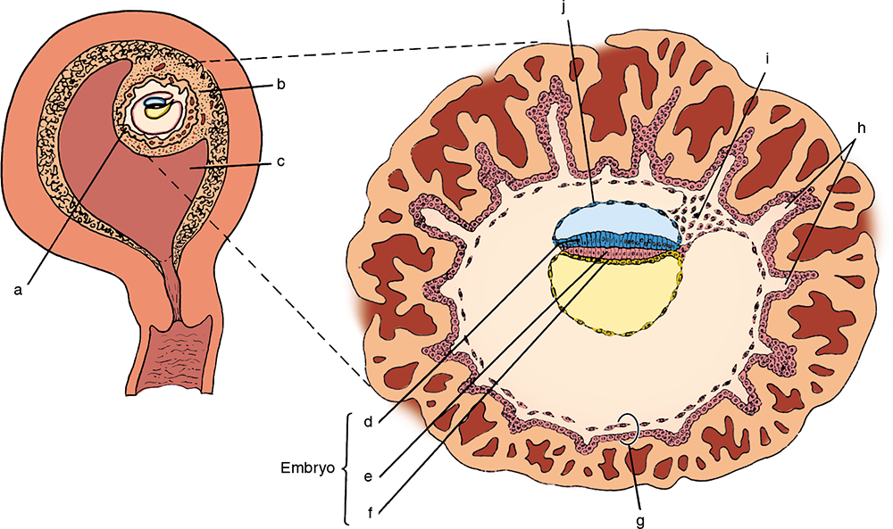
Figure 44.9-1 Full Alternative Text Description
- Explain the process and importance of gastrulation.

- What is the function of the amnion and the amniotic fluid?

- Describe the process of implantation, noting the role of the trophoblast cells.

- How many days after fertilization is implantation generally completed? What event in the female menstrual cycle ordinarily occurs just about this time if implantation does not occur?

- Referring to the illustrations and text of Life Before Birth: Normal Fetal Development, answer the following:
Which two organ systems are extensively developed in the very young embryo?
and
Describe the direction of development by circling the correct descriptions below:
  - proximal-distal
  - distal-proximal
  - caudal-rostral
  - rostral-caudal
Does body control during infancy develop in the same directions? Think! Can an infant pick up a common pin (pincer grasp) or wave his arms earlier? Is arm-hand or leg-foot control achieved earlier?

- Note whether each of the following organs or organ systems develops from the (a) ectoderm, (b) endoderm, or (c) mesoderm.
  - 1. skeletal muscle
  - 2. skeleton
  - 3. lining of the GI tract
  - 4. respiratory mucosa
  - 5. circulatory system
  - 6. epidermis of skin
  - 7. nervous system
  - 8. serous membrane
  - 9. liver, pancreas

In Utero Development
- Make the following comparisons between a human and the dissected structures of another pregnant mammal.

Figure 44.9-1 Full Alternative Text Description
- Where in the human uterus do implantation and placentation ordinarily occur?
- Describe the function(s) of the placenta.
- Which two extraembryonic membranes has the placenta more or less “put out of business”?

- When does the human embryo come to be called a fetus?
- What is the usual and most desirable fetal position in utero?
Why is this the most desirable position?

Gross and Microscopic Anatomy of the Placenta
- Describe fully the gross structure of the human placenta as observed in the laboratory.

- What is the tissue origin of the placenta: fetal, maternal, or both?
- What placental barriers must be crossed to exchange materials?
- Clinical/Critical Thinking Sexually transmitted bacteria, including the causative agents of gonorrhea and chlamydia, can damage a variety of pelvic organs, leading to a condition called pelvic inflammatory disease (PID). PID often leads to scarring of the uterine tubes. Explain how this could result in infertility in women.

- Clinical/Critical Thinking PID is also a risk factor for ectopic pregnancies, in which a fertilized egg implants outside the uterus. Explain the connection between PID and ectopic pregnancies.

