Virtual Lab: Hematocrit Test
- Hematocrit (HCT) is the percentage of erythrocytes, or red blood cells (RBCs), in a whole blood sample.
- Hematocrit (HCT) is determined by separating the formed elements from the plasma and measuring the packed red blood cell volume.
- Normal hematocrit varies depending on many factors, but generally accepted ranges are:
  - Adult males: 42–52%
  - Adult females: 37–47%
- An abnormally elevated hematocrit can occur for several reasons, such as being at a high altitude, having an elevated testosterone level, with certain diseases, and if the person is "blood doping."
- Blood doping refers to any of several methods used to increase the blood oxygen-carrying capacity.

- In this simulation, you will measure the hematocrit of three blood samples from athletes.
- Your task is to determine if any of the athletes are blood doping.
- You have blood samples of known values to compare. Positive control represents a doped sample. Negative control represents a sample that is not doped.
- Take a moment to reflect on personal safety precautions. Working with blood is a potentially hazardous situation. In real life, you should:
  - Wash the laboratory lab benches before and after the procedures with an appropriate disinfectant.
  - Wear disposable gloves and goggles when handling blood samples.
  - Wash your hands after the laboratory.
  - Only use a blood lancet once.
  - Dispose of used lancets, pipettes, and other blood contaminated items in the appropriate hazardous waste container, never a regular trash container.
Loading the Centrifuge
Centrifuge must be balanced to run properly. Remember to make sure each capillary tube has another directly across from it in the centrifuge.
Figure 1 Balanced Centrifuge with clay pointing peripherally
How to Measure
Measurement of the hematocrit is made simple by aligning the capillary tube to the hematocrit chart. To do this, move the capillary tube left or right along the chart such that the blood and clay are even with the bottom of the chart, and the top of the plasma is even with the top of the chart. Once you have aligned the capillary tube, click and you will see the measurement.
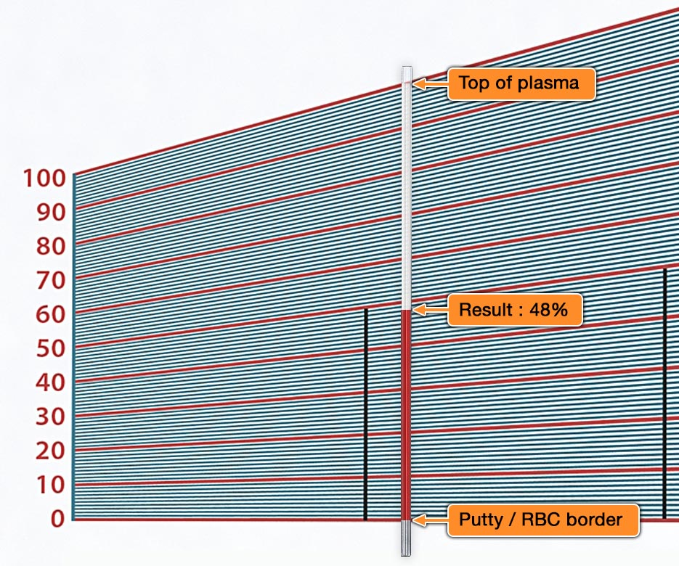
Figure 2 Reading hematocrit results of 48%

Virtual Lab: Hemoglobin Test
- Red blood cells (RBCs) are about one-third hemoglobin. Hemoglobin is the main protein that carries oxygen and some carbon dioxide in the blood.
- Healthy hemoglobin content in the blood varies with age, sex, and other factors. Generally, the values below are considered the normal range.
  - Male: 14–18 g Hb/100 mL
  - Female: 12–16 g Hb/100 mL
- The hemoglobin content of blood is one measure of the oxygen-carrying capacity of the blood.
- An abnormally elevated hemoglobin content will occur if someone is "blood doping."
- Blood doping refers to any of several methods used to increase the blood oxygen-carrying capacity.
- In this simulation, you will measure the hemoglobin content of three blood samples from athletes.
- Your job is to determine if any of the athletes are blood doping.
- You have blood samples of known values to compare. Positive control represents a doped sample. Negative control represents a sample that is not doped.
- Take a moment to reflect on personal safety precautions. Working with blood is a potentially hazardous situation. In real life, you should:
  - Wash the laboratory lab benches before and after the procedures with an appropriate disinfectant.
  - Wear disposable gloves and goggles when handling blood samples.
  - Wash your hands after the laboratory.
  - Only use a blood lancet once.
  - Dispose of used lancets, pipettes, and other blood contaminated items in the appropriate hazardous waste container, never a regular trash container.

- Blood must be placed in a chamber and stirred with a chemical to allow the hemoglobin to come out of the RBCs and into solution.
- The chamber is then placed into a hemoglobinometer, which reads the hemoglobin content based on how light passes through the hemoglobin solution.
Adjust the slider so the two green halves of the meter look the same.
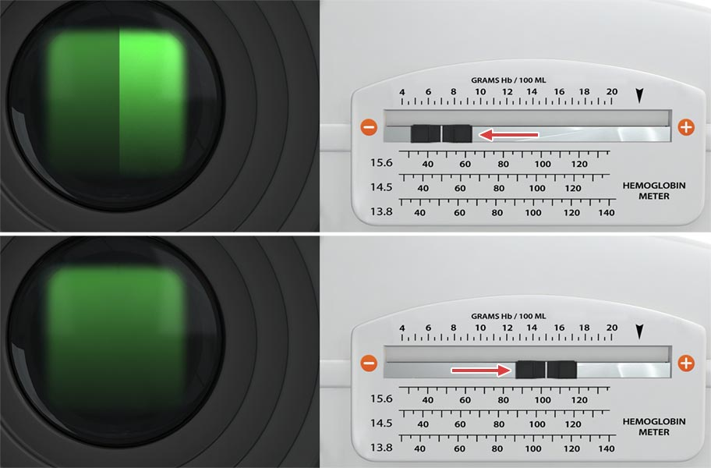
Figure 3 Hemoglobin meter with adjustment to make sure 2 green sides look the same
Read the hemoglobin content (in g Hb/100 mL) from the slider position. In this case, the meter reads 15 g Hb/100 mL
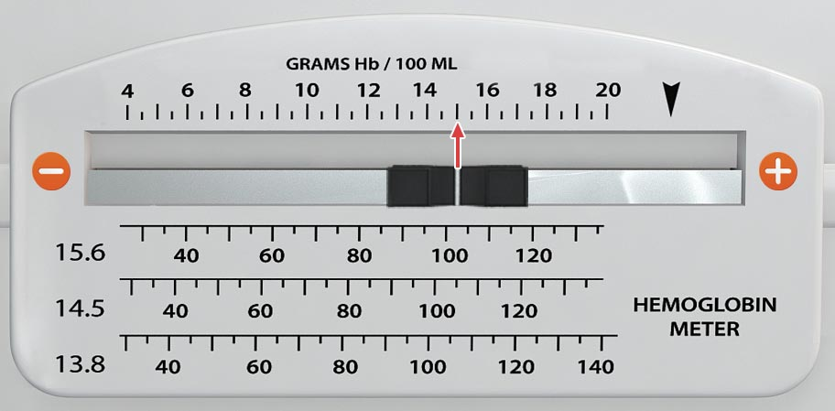
Figure 4 Hemoglobin meter reading 15 g of hemoglobin per 100 mL

Virtual Lab: Blood Typing
- Blood types are determined by the antigens that are present on the surface of red blood cells (RBCs, also known as erythrocytes).
- Red blood cell membranes contain glycoproteins and glycolipids that determine your ABO blood type and proteins that determine your Rh (+/-) blood type.
  - ABO blood type is determined by the presence of A, B, both (AB), or neither (O) of the A or B antigens.
  - Rh blood type is determined by the presence of (+) or lack of (-) the D antigen.
- The blood plasma may also contain antibodies, depending on the ABO and Rh blood types.
  - If you have blood type A, you will have anti-B antibodies.
  - If you have blood type B, you will have anti-A antibodies.
  - If you have blood type O, you will have both anti-A antibodies and anti-B antibodies.
  - If you have blood type AB, you will NOT have any anti-A nor anti-B antibodies.
  - No one has anti-D (Rh) antibodies unless they are Rh- AND have been previously exposed to Rh+ blood.
- Blood can only be donated from a person with a specific ABO antigen to a person without antibodies for that antigen. Otherwise, agglutination (clumping) will occur.
  - Type A cannot donate to Type B or Type O because they both have anti-A antibodies.
  - Type B cannot donate to Type A or Type O because they both have anti-B antibodies.
  - Type AB cannot donate to Type A because they have anti-B antibodies or Type B because they have anti-A antibodies.
  - Type O can potentially donate to everyone because their blood has no antigen to attack. However, Type O should first have its own anti-A and anti-B antibodies removed.
  - Rh+ blood should not be transfused to an Rh- person; however, Rh- blood can be donated to an Rh+ person.
- It is critical to know a person’s blood type prior to a blood transfusion.
- In this simulation, you will apply antibodies to blood samples to determine the ABO and Rh blood types of the samples.
- You will also determine which blood types can donate to one another.
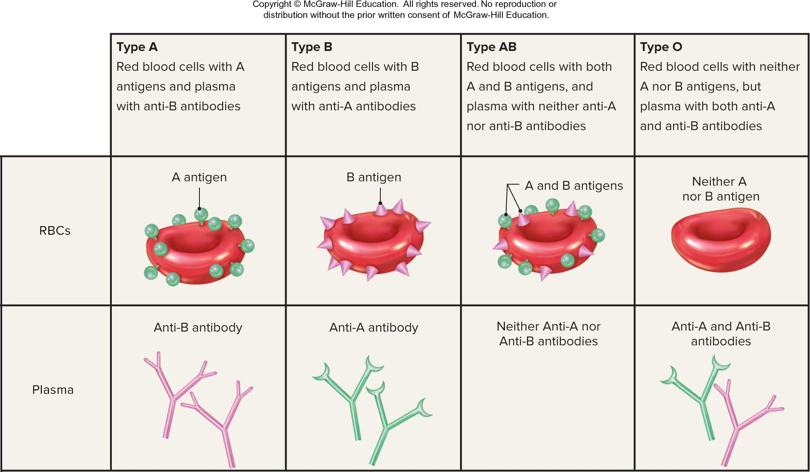
Figure 5 Antigen and Antibody Characteristics of ABO types. A has A antigens and Anti-B antibodies; B has B antigens and Anti-A antibodies; AB has both A and B antigens and no antibodies: O has no antigens and both Anti-A and Anti-B antibodies.

Take a moment to reflect on personal safety precautions. Working with blood is a potentially hazardous situation. In real life, you should:
- Wash the laboratory lab benches before and after the procedures with an appropriate disinfectant.
- Wear disposable gloves, lab coat, and goggles when handling blood samples.
- Only use a blood lancet once.
- Dispose of used lancets, pipettes, and other blood contaminated items in the appropriate hazardous waste container, never a regular trash container.
- Wash your hands after the laboratory.
The terminology used for blood typing can be confusing. Make sure you are familiar with the following terms:
Antigen: Any substance that is capable of causing an immune reaction. These are usually proteins, glycoproteins, or glycolipids.
Antibody: An immune system protein that is found in most body fluids, especially blood plasma. Antibodies bind to antigens to aid the immune response.
Agglutination: The clumping of cell bound antigens, as occurs when antibodies attach to ABO and D (Rh) antigens.
Agglutinogen: The substance being clumped in an agglutination reaction. Antigens in blood typing are agglutinogens.
Agglutinin: The substance causing clumping in an agglutination process. Antibodies in blood typing are agglutinins.
Positive: Does NOT mean “good.” In testing, positive means what you are testing for is present.
Negative: Does NOT mean “bad.” In testing, negative means what you are testing for is absent.
Serum/Sera: Fluid containing antibodies.

Blood Typing: Recognize agglutination
Agglutination in blood typing is the clumping of red blood cells caused by antibodies binding to the antigens on the surfaces of red blood cells.
In the blood typing card shown below, the areas depicting agglutination are circled.
The sera that cause agglutination determine the blood type, as shown in the third column.
How to Interpret
Blood will agglutinate (clump) if the red blood cells (RBCs) have the antigens for the applied antibody serum. The samples that agglutinate determine the blood type.

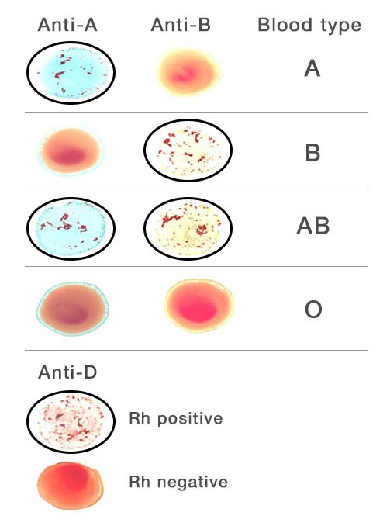
Figure 6 Agglutination with Anti-A shown with type A blood: Agglutination shown with Anti-B with B blood; Agglutination shown with both Anti-A and Anti-B with type AB blood; No agglutination shown with type O blood. Agglutination shown with Anti-D serum for Rh +
- Anti-A means antibody A, which binds to antigen A.
- Anti-B means antibody B, which binds to antigen B.
- Anti-D means antibody D, which binds to antigen D.
  - Anti-D serum is used to test for Rh factor. Agglutination of the anti-D sample means the blood is Rh positive.
The sera that cause agglutination determine the blood type, as shown in the "Blood Type" column in Figure 6.
- When only anti-A causes agglutination, the blood type is A
- When only anti-B causes agglutination, the blood type is B
- When BOTH anti-A and anti-B cause agglutination, the blood type is AB
- When neither of the sera causes agglutination, the blood type is O
Anti-D serum is used to test for Rh factor.
- Agglutination of the anti-D sample means the blood is Rh positive
- Without agglutination of anti-D, the blood is Rh negative
Try an example:
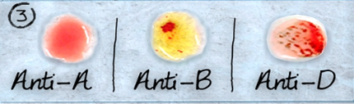
Figure 7 This is type B+ blood
- Anti-A shows no agglutination
- Anti-B shows agglutination
- Anti-D shows agglutination
- In Figure 7, and using the blood typing card for reference, you should recognize this as a sample of B+ blood

