Virtual Lab: Pulmonary Function Tests
- Completion of this laboratory requires that you have some prior basic knowledge regarding lung volumes.
- Air flow can be measured to create air flow-volume loops and diagnose lung diseases.
- A respirometer can be used to measure lung volumes and capacities.
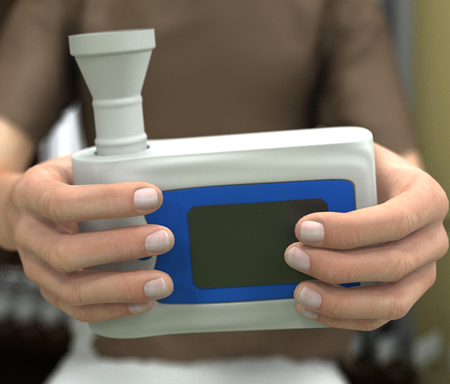
Figure 1 Respirometer
- In this lab, you will perform respirometry on several patients to perform pulmonary function tests and diagnose pulmonary diseases.
- The computer screen in the lab will have two tabs with reference material:
  - Lung Function Diagnosis: a chart of measured lung values and diagnosis parameters.
  - Disease Diagnosis: a chart of patient histories and symptoms that indicate diseases.
- Average values given in this simulation are for a healthy adult male patient.
- Obstructive lung disorders result in a flow of air that is less than it should be.
- Restrictive lung disorders have a normal flow of air but a low vital capacity and low inspiratory and expiratory volumes.
- Use the patient history chart to formulate a hypothesis regarding each patient.
- Use the lung volume test and flow-volume loop analysis to diagnose each patient.
Make sure you are comfortable with the following terms:
Tidal volume (TV)
Volume of air in each breath during regular breathing.
Inspiratory reserve volume (IRV)
The additional volume of air that can be moved into the lungs above tidal volume.
Expiratory reserve volume (IRV)
The additional volume of air that can be moved out of the lungs below tidal volume.
Vital capacity (VC)
The total amount of movable air. This is TV+IRV+ERV.
Forced vital capacity (FVC)
The total amount of air forcefully exhaled from fully inflated lungs. This is how vital capacity is measured.
Forced expiratory volume 1 (FEV1)
The percentage of the FVC that is expired in 1 second.
Forced expiratory flow 25-75 (FEF25-75)
The average flow rate of the middle half of the FVC.

Understand the graph shown below.
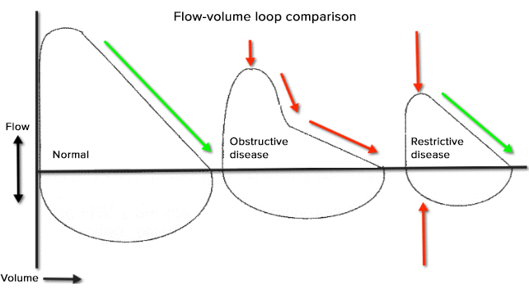
Figure 2 Normal flow-volume has rapid rise with inhalation then linear fall as person exhales. Obstructive disease has decreased air flow and prolonged non-linear exhalation. Restrictive disease has significant decreased inhalation and exhalation volumes.

- Flow-volume loop analysis will confirm the diagnosis of an obstructive or restrictive lung disease.
- Pulmonary volume tests are used in conjunction with flow tests (FEV1 and FEF25-75) to differentiate obstructive and restrictive lung diseases.

