Virtual Lab: Pulse Measurements
- A pulse is felt as the expansion of the arteries during ventricular systole (contraction).
- Pulse rate is the number of heart beats per minute and is one way heart rate (HR) is measured. As a result, pulse rate equals heart rate.
- A pulse can be detected in several superficial arteries in the body.
- Pulse rate can be influenced by body position, activity, and emotions.
- Determination of heart rate is one method to evaluate an individual's health. Heart rate can influence how much blood the heart pumps in a given amount of time and the amount of blood delivered to tissues in the body.
- In this simulation, you will:
  - Identify and locate various pulse rate locations.
  - Measure and compare the pulse rate of different arteries.
  - Compare the relative intensity of the pulse within different arteries.
  - Compare the pulse rate of the body in the following positions: sitting, lying down, and standing.
  - Compare the pulse rate at rest and after exercising.
- Generation of the Pulse
Pulse is felt as the expansion of the arteries during ventricular systole
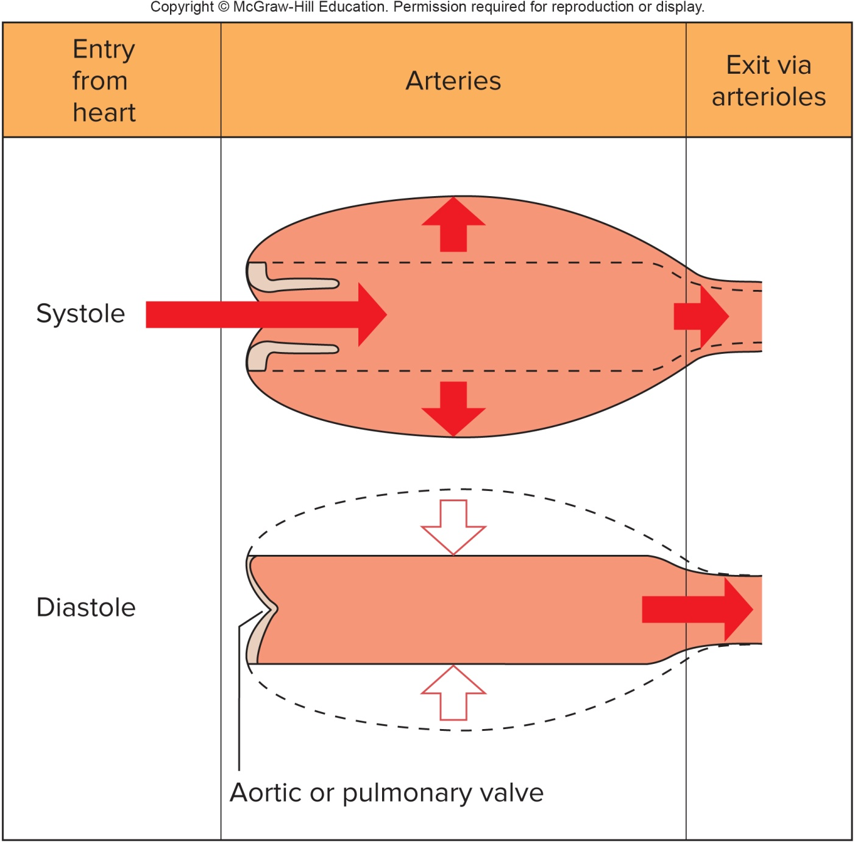
Figure 1 Pulse is generated as blood is pushed outward during systole and then retracts during diastole.

It is important to know the different locations a pulse can be palpated in a human body. The following describes general locations to palpate a few common pulse points:
Brachial artery
Palpated within the front of the elbow (antecubital region)
Common carotid artery
Palpated within the side of the neck (cervical region)
Dorsalis pedis artery
Palpated on the top of the foot (dorsum of foot)
Femoral artery
Palpated within the groin (inguinal region)
Popliteal artery
Palpated within the back of the knee (popliteal region)
Posterior tibial artery
Palpated between the medial side of ankle and Achilles tendon (between medial malleolus and calcaneal tendon)
Radial artery
Palpated on the thumb side of the wrist

