URINARY SYSTEM: URINALYSIS Virtual Lab

Key Concepts
- Urine formation is critical to our health. It is a mechanism the body uses to maintain normal blood composition, such as blood pH, and allows for the removal of waste products.
- In fact, the body must produce at least 0.5 liters of urine per day to adequately remove waste from the body. The amount of urine produced will vary based on fluid intake, blood pressure, and temperature, amongst other factors.
- Each kidney filters approximately 1 liter of blood per minute.
- Located within the cortex and medulla of the kidney are approximately 1 million microscopic nephrons in each kidney. The nephron is the functional unit of the kidney and forms urine.
- Blood is filtered from the glomerulus, a capillary bed, into the glomerular capsule through hydrostatic pressure.
- The fluid, now called filtrate, then enters the renal tubule where it is then termed tubular fluid. 99% of the filtrate created will be reabsorbed during the process of urine formation.

Nephron Anatomy
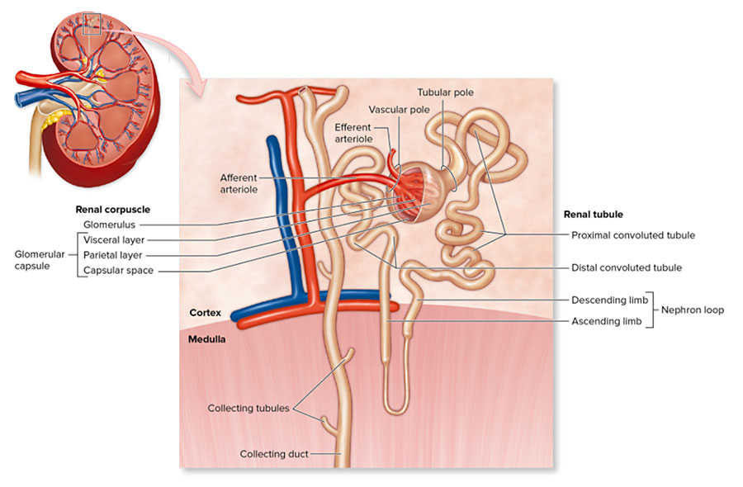

Overview
- Urine can be characterized by its composition, volume, specific gravity, color, transparency, and smell. Determining the composition of urine provides a great deal of information about the health of the individual. Both physical characteristics and chemical composition can be examined.
- Analysis of a patient's urine is an easy, non-invasive, and quick way to determine if some diseases or infections are present.
- Abnormal urine composition may indicate disease. For example, the presence of glucose in urine may indicate diabetes.
- In this simulation, you will perform a urinalysis of three samples of urine using the dipstick method. You will analyze the urinalysis for evidence of abnormality by comparing the results to a standard reference chart.
- Take a moment to reflect on personal safety precautions. Working with urine is a potentially hazardous situation. In real life, you should:
  - Wash the laboratory lab benches before and after the procedures with an appropriate disinfectant.
  - Wear disposable gloves, lab coat, and goggles when handling urine samples.
  - Dispose of urine-contaminated items in the appropriate hazardous waste container. Never use a regular trash container.
  - Wash your hands after the laboratory.

Dipstick Urinalysis
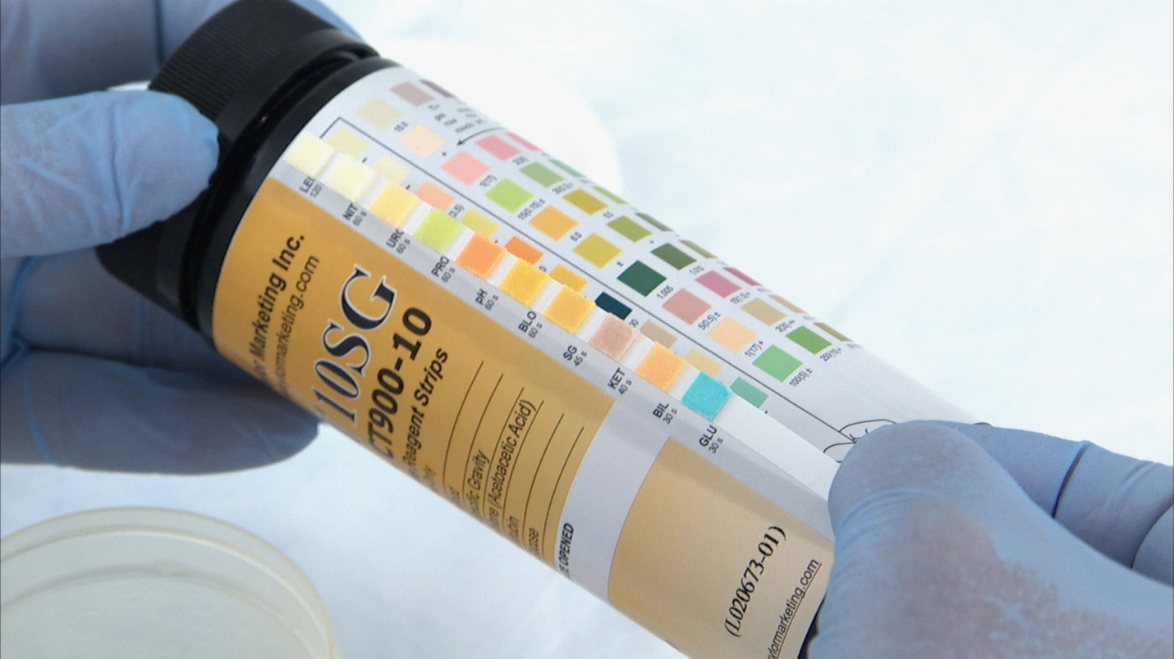

Before you begin
- Fresh urine is normally clear and pale yellow. Darker-color urine indicates the urine may be more concentrated. Cloudy urine may indicate the presence of a urinary tract infection.
- Urine Color Variation
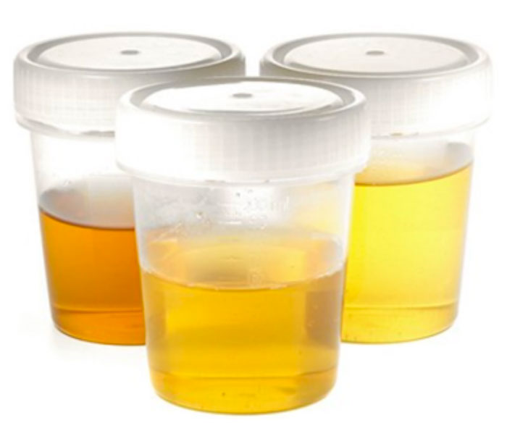
- Urine pH ranges from 4.5 through 8.0 depending on diet and the body's needs. A pH of 6.0 is typical.
- Normal healthy urine is sterile and formed from filtered blood. It is mostly water with solutes such as salts (Na⁺, K⁺, Cl⁻, Ca²⁺, Mg²⁺, H₂PO₄⁻, SO₄²⁻, NH₄⁺), nitrogenous wastes (urea, creatinine, uric acid), some hormones, and small quantities of ketones. Some drugs can also be found within urine.
- The presence of glucose, blood (erythrocytes), leukocytes, excess protein, or ketones is abnormal and indicates infection or disease.
- Glucose is normally fully absorbed back into the body from the filtrate. Its presence in urine indicates abnormally high levels of glucose, such as that found in diabetics.
- Erythrocytes (red blood cells) are not normally found in urine as they should not be able to pass through the filtration membrane. Their presence indicates disease or infection.
- Leukocytes are part of the immune response and should not be found in urine. The presence of leukocytes indicates infection, such as a kidney or urinary tract infection.
- Protein is not usually found in urine as it cannot typically pass into the filtrate. Presence of excess protein, known as proteinuria, may indicate problems with the kidney.
- Ketones are formed during fatty acid metabolism. A small amount of ketones in urine is normal. However, excessive ketones in urine is a sign of diabetes.
- To perform a dipstick urinalysis, a special stick with chemically-treated pads is inserted into a urine sample. Each chemically treated pad is coated with reagents that test for the presence of a variety of substances; such as pH, glucose, and leukocytes.
- The chemically treated pads are fully and quickly inserted into the urine sample, allowed time to react, and finally compared to a chart of standards.
- When the sample is compared to the standards, make sure to hold the test strip over standard for a direct comparison.
- How to compare a urine test strip to a reference chart
- 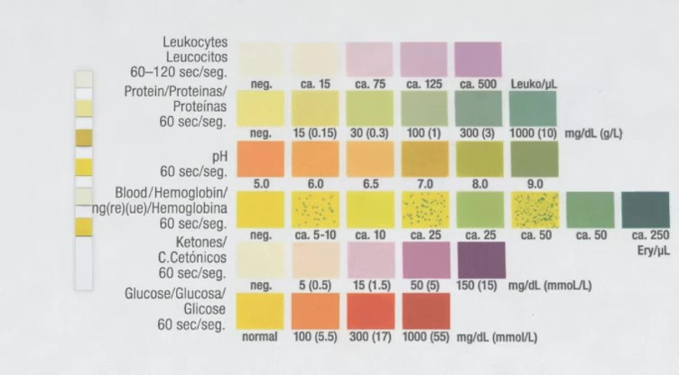
In the example shown above, the first test pad is being compared to the first test for leukocytes. The color of the test pad matches the color chart for standards for negative. The urine is negative for leukocytes. The second test pad is being compared to the second test for protein. The urine is negative for protein. The third test pad is being compared to the third test for pH. The urine has a pH of 7. The urine dipstick shown here includes pads for six tests.
To read the test, align each pad with the key that matches for that test.
Make sure you are familiar with the following terms:
Turbidity
The cloudiness of a solution. Healthy urine is clear. Cloudy or turbid urine indicates the presence of an infection
Leukocytes
Leukocytes are also known as white blood cells. They are part of the immune response and are not normally found in the urine of a healthy individual. The presence of leukocytes in urine indicates infection.
Protein
A small amount of protein in urine is normal. Excess protein in urine, called proteinuria, is abnormal and may indicate the kidneys are not functioning correctly.
pH
pH is a measure of the concentration of hydrogen ions in solution. It is a measure of the acidity or alkalinity of a solution. The normal pH of urine ranges between 4.5-8, with an average of a pH of 6. The pH of urine can vary with diet or infection.
Blood
Blood is a connective tissue composed of plasma, erythrocytes (red blood cells), leukocytes (white blood cells), and platelets. Erythrocytes or leukocytes are not normally found in urine. Their presence may indicate infection or disease.
Hemoglobin
Hemoglobin fills erythrocytes (red blood cells) and functions to transport gases through the body, such as oxygen. The presence of hemoglobin indicates blood is present.
Ketones
Ketones are compounds produced in the body during fatty acid metabolism. Ketones can easily pass through the filtration membrane of the nephron and are not normally found in urine. The presence of ketones may indicate disease, such as diabetes.
Glucose
Glucose is a common monosaccharide the body uses to synthesize ATP. Glucose is completely reabsorbed from filtrate in a healthy individual. The presence of glucose in urine is typical of diabetes.

