Comparative Vertebrate Anatomy
Sample Laboratory Assignment
August 31, 2022
Clare Hays

Table of Contents
Cover Page...............................................................................................................................1
Table of Contents…………………………………………………………………………………………………..……………2
Answers to Laboratory Objectives……………………………………………………………………………………….3
Bony Fish Skeleton...................................................................................................................4
Human Skeleton
Skull..............................................................................................................................5
Pectoral Girdle and Appendage...................................................................................6
Pelvic Girdle and Appendage.......................................................................................7
Resources..................................................................................................................................8

Answers to Laboratory Objectives
Chapter 3
2 points 1. Classify Amphioxus (=Branchiostoma) in the appropriate phylum and subphylum. Phylum Chordata, Subphylum Cephalochordata
Chapter 14
2 points 1. Classify lampreys in the appropriate phylum and subphylum. Phylum
Chordata, Subphylum Vertebrata
2 points 2. What is the difference between the terms myotome and myomere? Myomere – muscle segment in adult form. Myotome – muscle segment in an immature form.

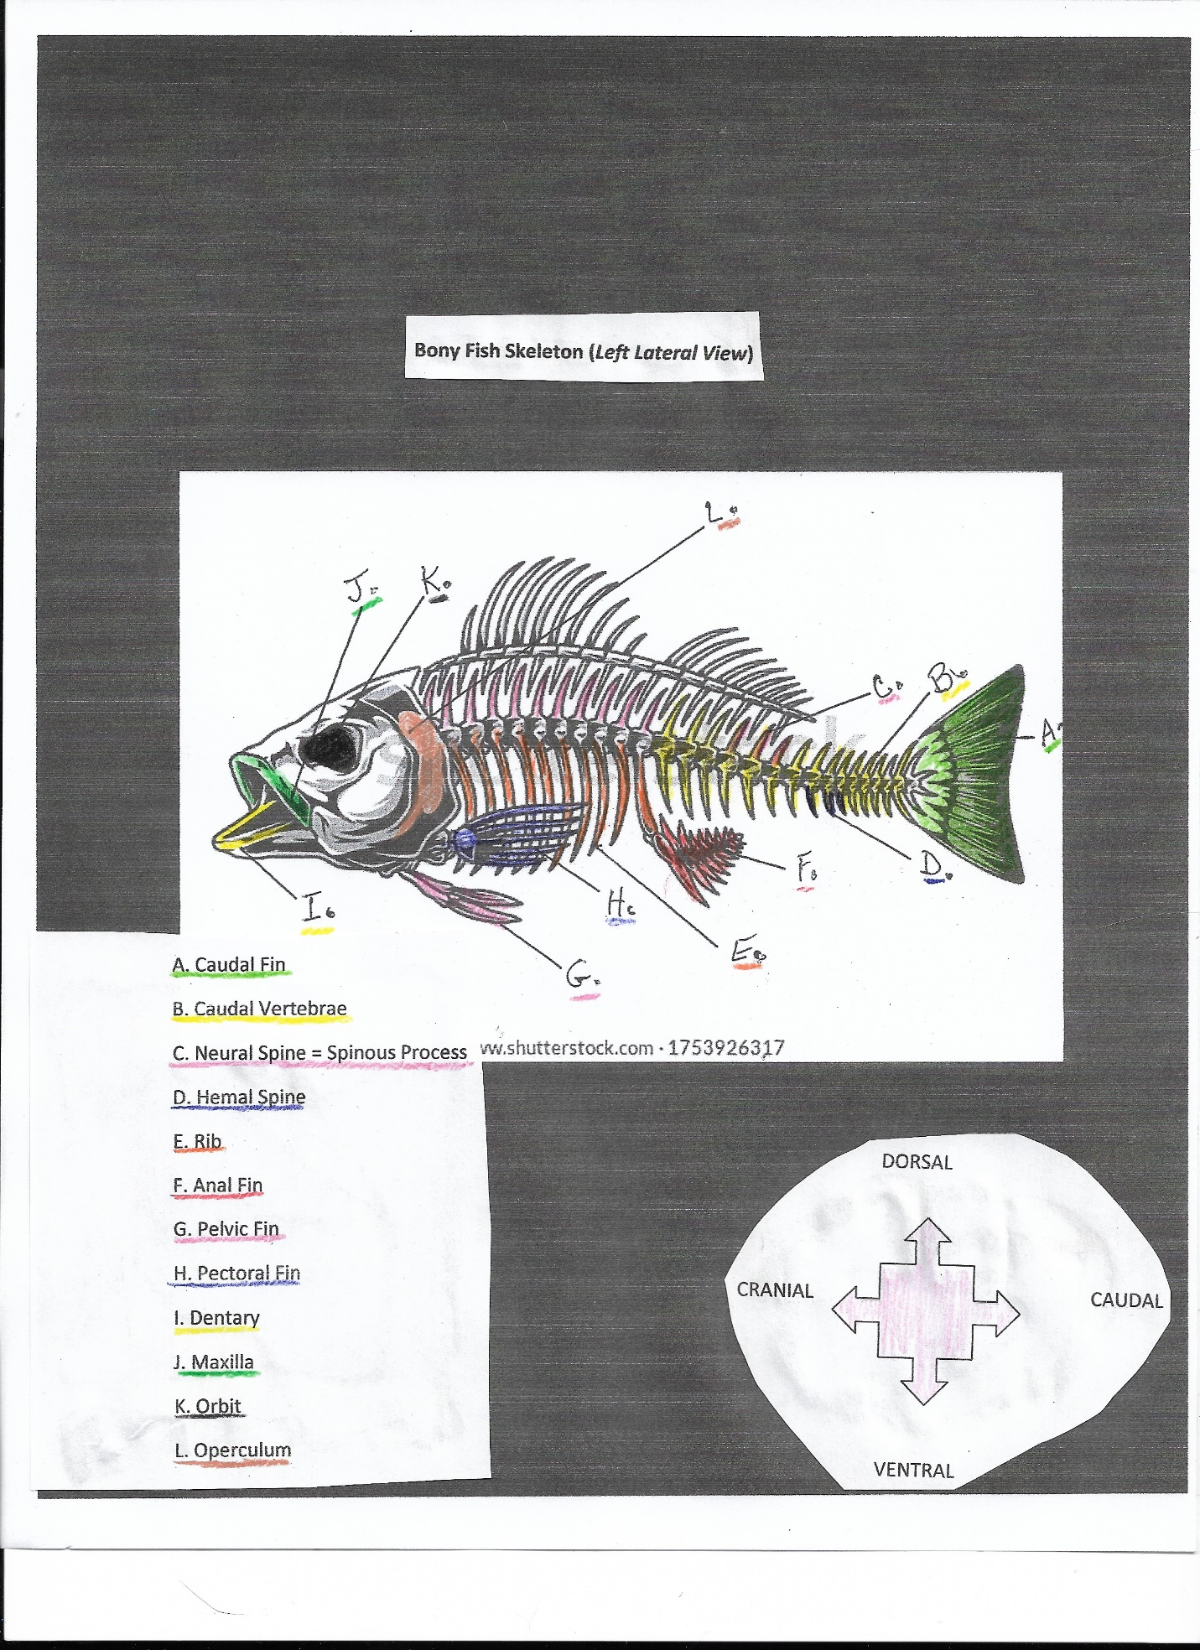
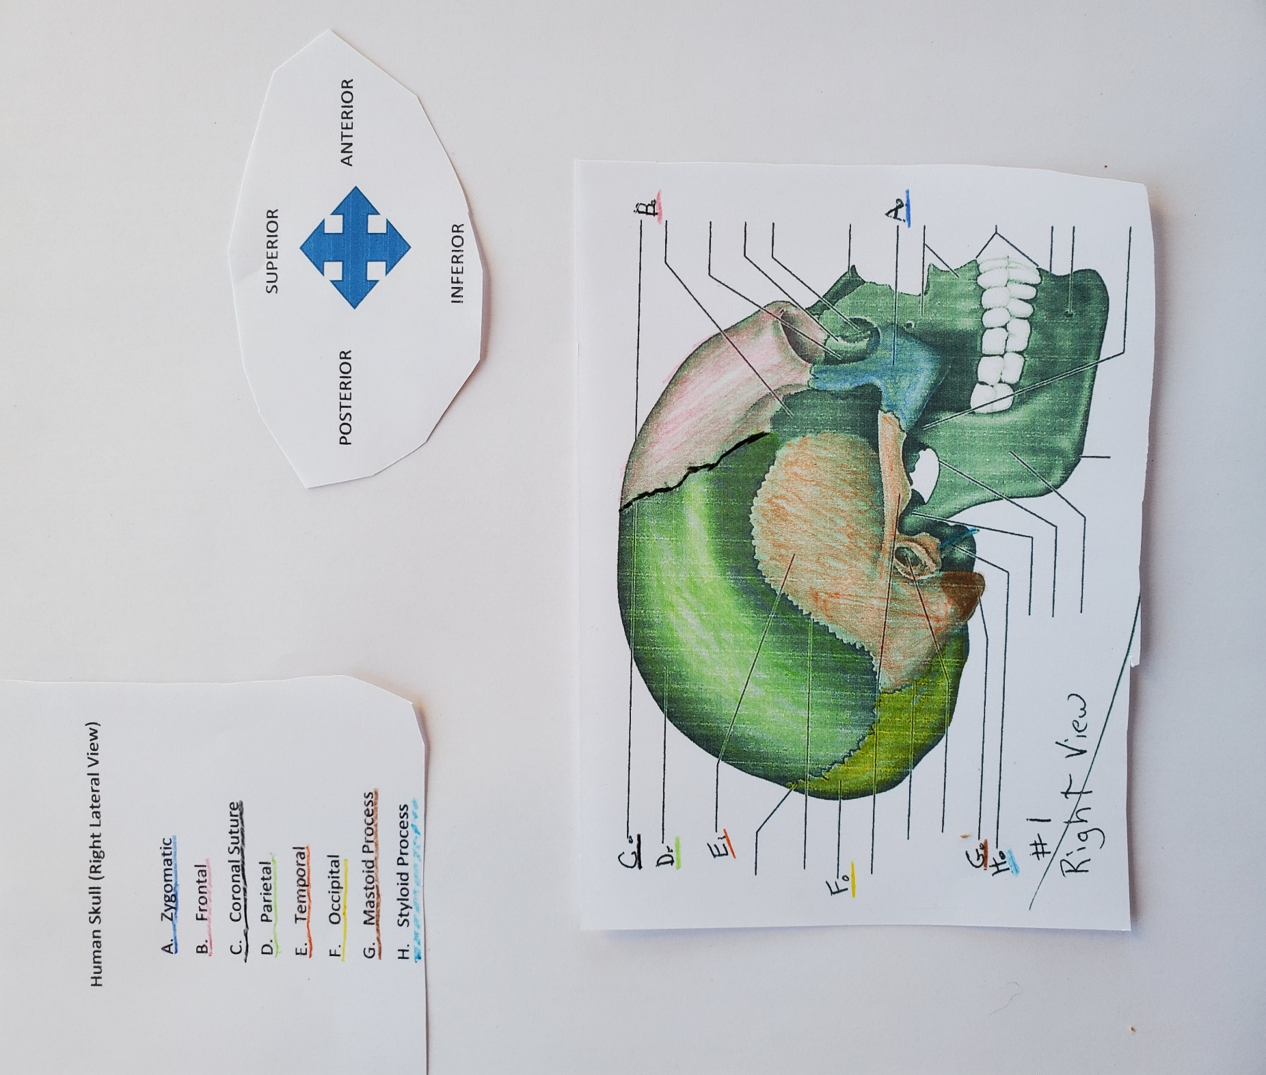
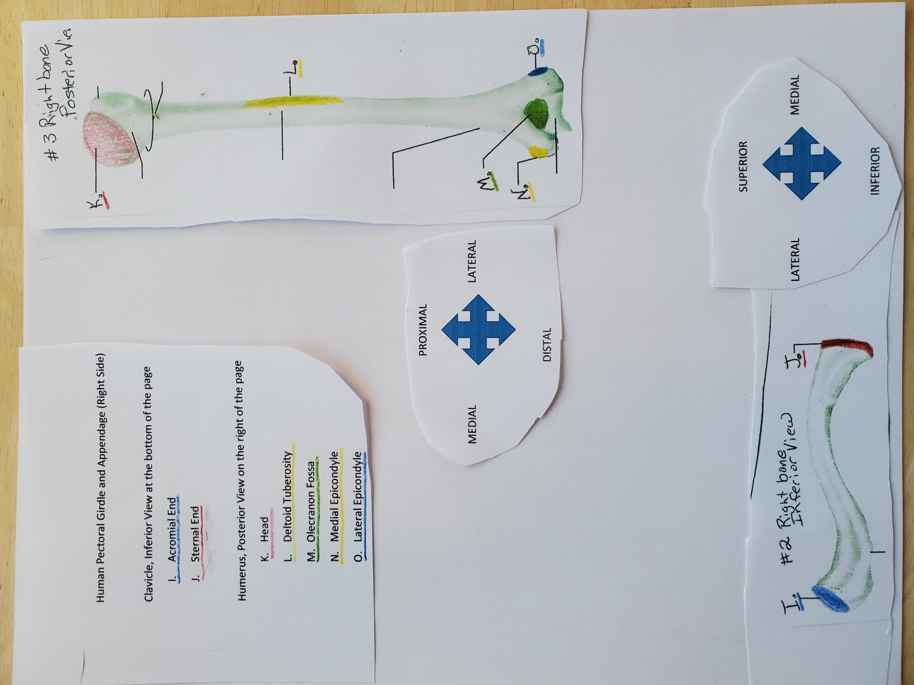
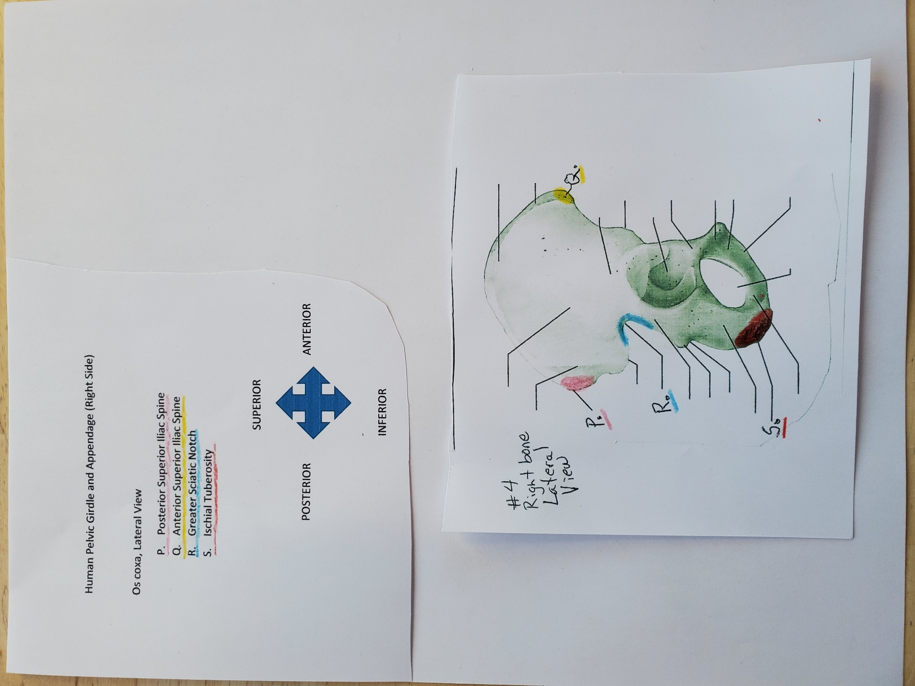

References

Fishbeck, D.W. & Sebastiani, A.M (2015). Comparative Anatomy Manual, of Vertebrate Dissection, 3rd Edition. Morton Publishing Company.

Swislosky, E. & Roosa, K. (2017). Atlas of Comparative Anatomy. Lumen Learning. https://louis.oercommons.org/courses/atlas-of-comparative-vertebrate-anatomy/view

