Mechanism of Breathing Virtual Lab Key Points
Key Concepts
- Skeletal muscles, especially the diaphragm, change the volume of the thoracic cage.
- The lungs change volume with the thoracic cage because the parietal and visceral pleurae attach the lungs to the inside of the pleural cavity.
- Air pressure gradients are developed between the lungs and external environment due to volume changes.
- Air flows into and out of the lungs down its pressure gradient.
- The concepts related to these changes are described in Boyle’s law.
- Boyle's law
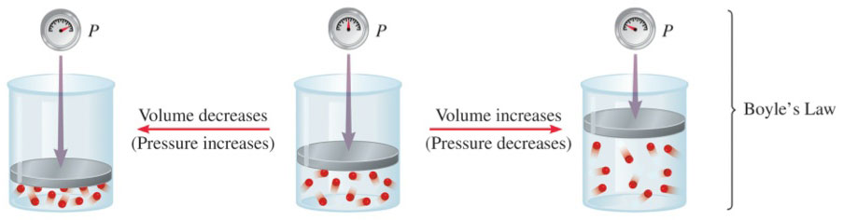

- Normal inspiration
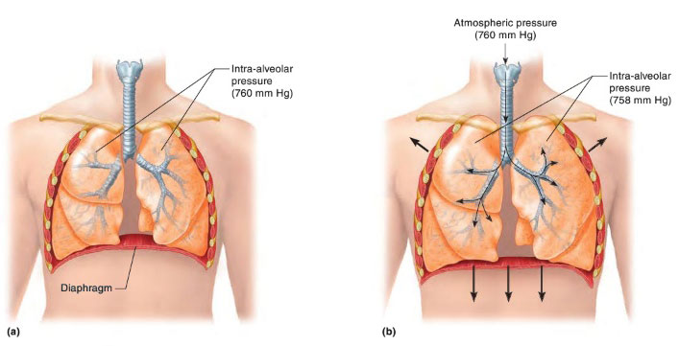

Make sure you are familiar with the following terms:
Atmospheric pressure
Pressure of air in the atmosphere; i.e., outside of the body and lungs.
Intra-alveolar pressure
Pressure of air in the alveoli (air sacs) of the lungs; i.e., inside the body and lungs.

Intrapleural pressure
Pressure existing in the pleural cavity between the parietal pleura lining the pleural cavity and the visceral pleura covering the outside of the lungs.

