Human Genetics Chromosomal Inheritance During Meiosis Virtual Lab Key Points

Key Concepts
- Many human traits are inherited in specific, predictable patterns.
- Meiosis is the type of cell division required for gametogenesis.
- Gametogenesis in males is called spermatogenesis and produces sperm.
- Gametogenesis in females is called oogenesis and produces ova.
- The process of oogenesis only completes if fertilization occurs.
- In humans, meiosis produces cells called gametes that contain half the amount of genetic material as the parent cell. In the process of meiosis, several mechanisms shuffle the genetic material, thereby increasing genetic diversity.
- Many human genetic disorders are the result of errors in gametogenesis.
- Nondisjunction is an error where the chromosomes, or sister chromatids, do not properly split during meiosis.
- Nondisjunction can happen in meiosis I or meiosis II.
Here are the Phases of Meiosis
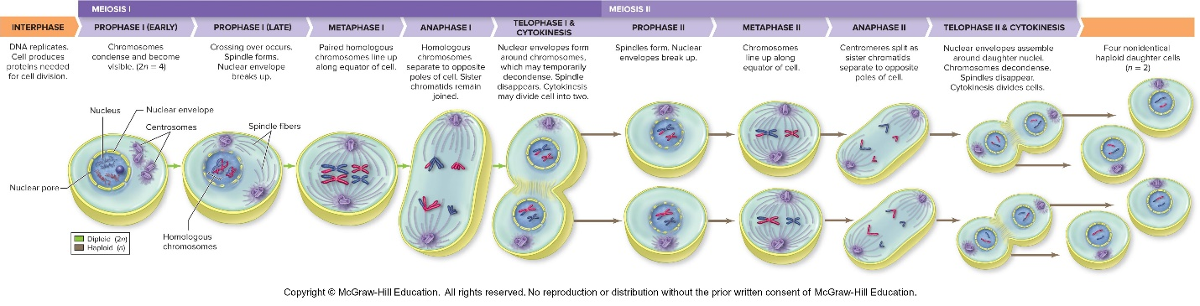
- In this simulation, you will learn the names of and be able to place the phases of meiosis I and meiosis II into sequence.
- You will learn how nondisjunction produces gametes with incorrect numbers of chromosomes.
- You will also be able to identify the phases of meiosis in which nondisjunction could occur.
Nondisjunction during Meiosis I
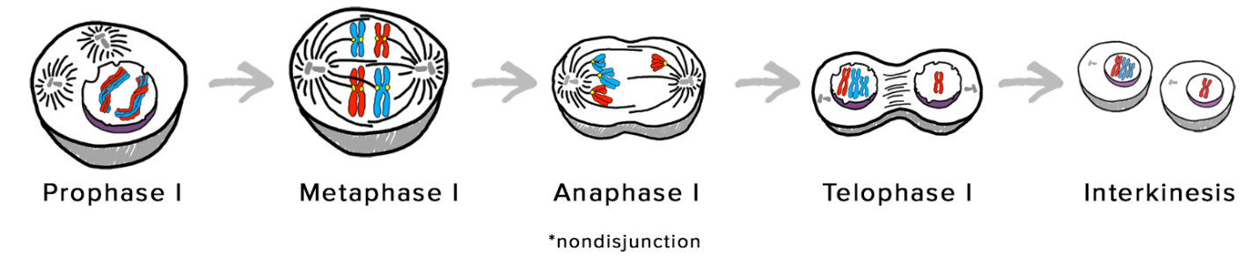
Nondisjunction during Meiosis II
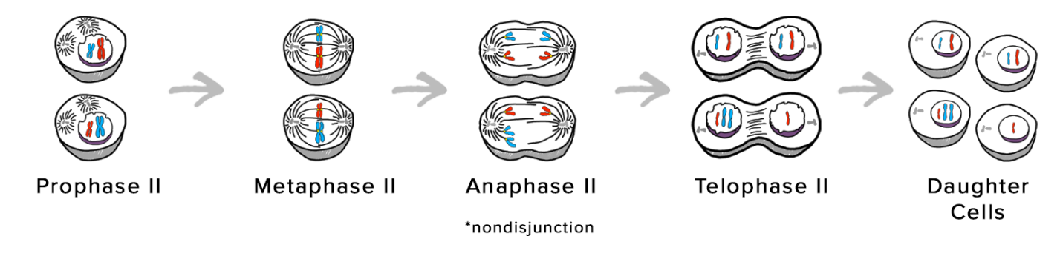
- Meiosis consists of two main phases: meiosis I and meiosis II.
- The phases of meiosis I are: prophase I, metaphase I, anaphase I, and telophase I, followed by a brief pause called interkinesis.
- The phases of meiosis II are: prophase II, metaphase II, anaphase II, and telophase II.
Make sure you are familiar with the following terms:
Homologous chromosomes
A pair of matching autosomes with similar genes
Sister chromatids
Replicated chromosomes composed of two identical attached copies
Autosomes
22 pairs of chromosomes in humans that are identical for both sexes
Diploid
State of a cell with two copies of homologous chromosomes. Humans have 23 pairs of chromosomes
Haploid
State of a cell with one copy of each chromosome. Human gametes have one copy of 23 chromosomes.
Interkinesis
Brief pause between meiosis I and meiosis II in which no DNA replication occurs
Nondisjunction during meiosis I
Failure of homologous chromosomes to separate during anaphase I.
Nondisjunction during meiosis II
Failure of sister chromatids to separate during anaphase II.

