**Using Sharpen study app by McGraw Hill**

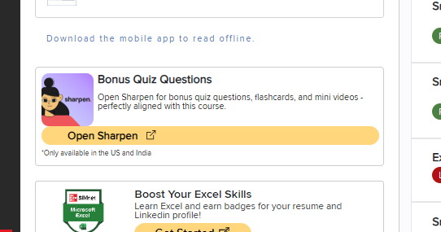

**Launching Sharpen**

"Open Sharpen" from left side of Connect Homepage. Finish any account information and click "Finish". If using your phone, download the Sharpen app and click Sign In. Enter your Email address that you use for Connect. They will send a code via that Email to enter on your app. Start Learning.

Once your Sharpen app is set up, click on the “Library” menu at the bottom and choose **Sharpen Anatomy & Physiology** concepts and click on it.

**Assigned Chapters and Deadlines**

You’ll earn 5 points for each chapter where you score a 'B-' or higher, based on the progress shown for assignments completed by the due dates in your syllabus.

-Sharpen Assignment One: Chapters 1,2,3,4,6,7, and 8 by end of Week 4 (when Lecture Exam 1 is due)

-Sharpen Assignment Two: Chapters 9 and 10 by the end of Week 8

-Sharpen Assignment Three: Chapters 11,12,13 by the end of Week 12

-Sharpen Assignment Four: Chapters 14 and 15 by the end of the semester

(Note that these chapter numbers vary slightly from the chapters in your gold Van Putte Smartbook.)

**Steps to Complete a Chapter**

To complete a chapter, receive a grade from the app, and points from your teacher, follow these steps:

1. Click the arrow to the right of the chapter which brings you to a screen of Videos (Understand on phone), Quiz banks (Test your knowledge on phone) and Flashcards (Memorize on your phone).

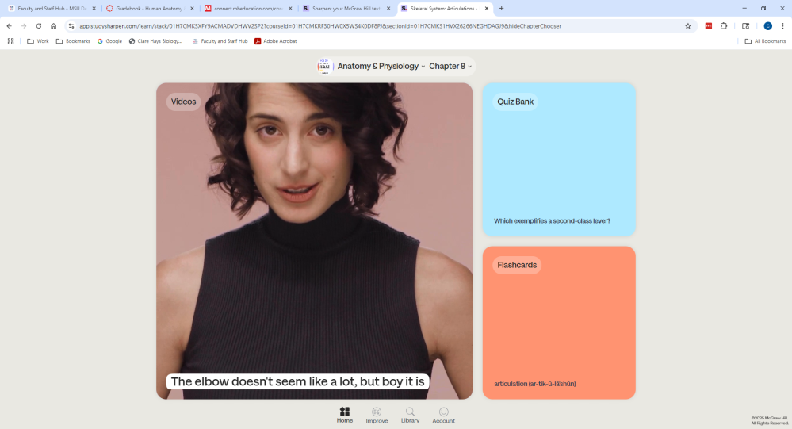

2. First click on videos and watch all the videos associated with that chapter. This will be the “Understand” option on your phone. You will see a green check appear next to videos that you have viewed. Here is an example below of all videos completed for Chapter 8 on Articulations.

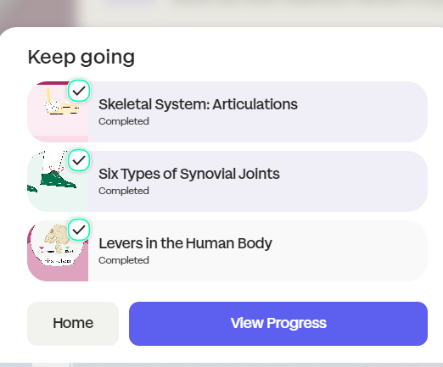

3. Now do the flashcards which cover terminology associated with that chapter. You can always access them by clicking the "Home" button and making sure you are in the correct chapter from the drop-down menu at the top or by clicking the "Improve" button at the bottom and then the arrow on the chapter you are working on. On your phone the flashcards are the “Memorize” button. You click on each flashcard to see the definition of the terms. Then click "Next" on computer or swipe right on your phone. You will benefit from using the phonetic pronunciations of the complex terms and saying them out loud. The progress bar will be green once completed.

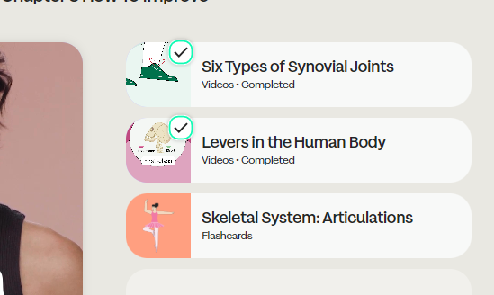

This shot above shows that the videos are complete but **not** the flashcards.

Once the flashcards are completed, you will see a check inside of a green circle showing that the flashcards are complete as shown below.

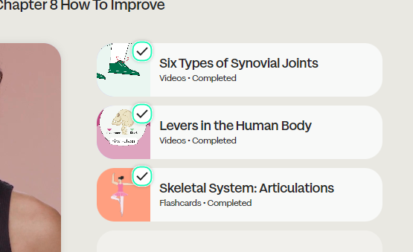

4. Last take the tests associated with that chapter. You get to the quizzes by returning to “Home” with the icon on the bottom of the page. If it doesn't default to the chapter you are working on, then use the drop-down menu at the top to find the correct chapter.

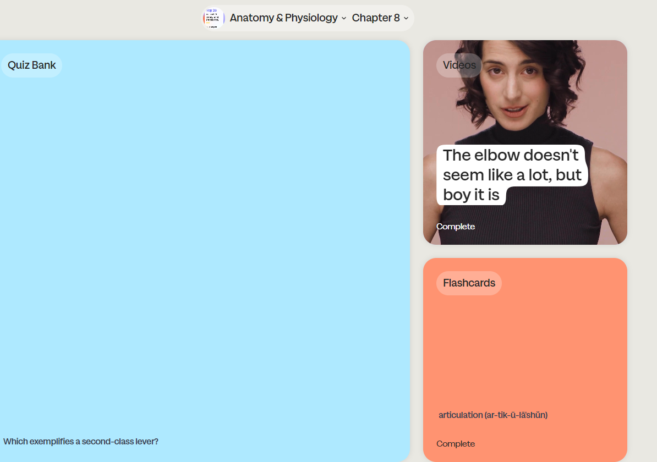

When you click on “Quiz Bank” on your computer or “Test your Knowledge” on your phone, there are three quiz types. Start with Basic, then do Advanced, and then do Exam. You can observe the progress on the exam with the bars that turn green upon completion. Note that the “Exam” questions are identical to the "Basic" and "Advanced" exam questions.

5. Note that once this chapter (8 in my example) is finished (videos, flashcards and the tests), you can click on the “Improve” button and under Knowledge chapter 8 is listed with a grade under Progress. Take a screenshot of your Progress. You will receive 5 points for every chapter completed with a “B-” or better by the deadlines described above.

**Uploading Screenshot to Canvas**

1. How to receive those points? Upload a screenshot on Canvas of your Progress showing which chapters are completed with a grade of “B-” or better by the deadlines listed above.

Here is an example of a screenshot showing Chapters 1,5, and 8 are completed.

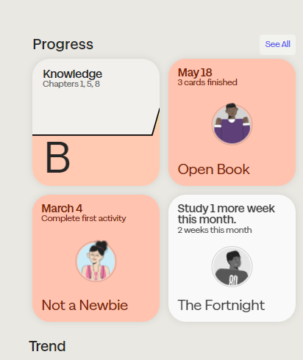

2. How to upload to Canvas: Click on the list of Assignments from the left menu on Canvas. Click on the appropriate assignment (for example Sharpen Assignment One). Then click on the “Start Assignment” on Canvas for each Sharpen assignment that you may find on the Assignments tab.  Then, you have the option to upload a file from your computer.  Once it is uploaded, click “Submit Assignment.”  Each completed and assigned Sharpen chapter shown on the Knowledge Progress bar will earn you 5 points as long as it is submitted by the deadlines listed above.